A2+ LESSON 8

**PASSIVE VOICE:**

**Active voice**

**Passive voice:**

Tom writes novels

Novels are written by Tom

BE+ VERB3RD

**PRESENT:**

Ana cooks pizza. Columbus discovered America

Pizza is cooked by Ana. America **was** discovered by Columbus

1. DO---what?
2. Do-----subject
3. Be---tense
4. Verb----3rd
5. By+ doer

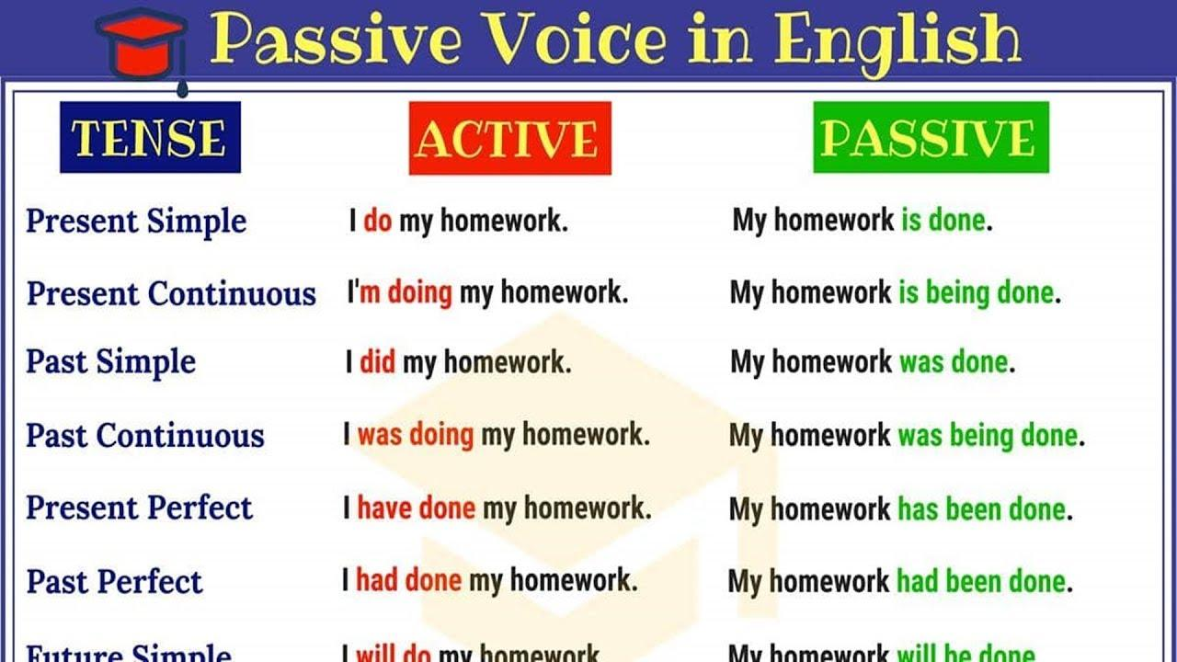

He writes emails.

She texted Richard.

We study English grammar.

The company sells products.

My brother visited our grandparents.

The mechanic fixes the car engine.

The artist painted a beautiful picture.

The waiter serves the customers.

The police caught the thief.

The storm damaged the roof of the house.

1. Tennis  on a clay, grass or hard court. **(PLAY)**
2. In this hospital small injuries  by assistant doctors. **(TREAT)**
3. The wheel  thousands of years ago **(INVENT)**
4. English  in many countries all over the world. **(SPEAK)**
5. India  independence after the end of World War II **(GIVE)**.
6. The goals  in the first 15 minutes of the match **(SCORE)**.
7. New medicine for many diseases  every year. **(FIND)**
8. America  by Christopher Columbus in 1492 **(DISCOVER)**
9. Breakfast  from 7 a.m. to 10 a.m. **(SERVE)**
10. The thief  to the nearest police station. **(TAKE)**
11. Every day CNN  by millions of people . **(WATCH)**
12. Coffee  to Europe by the Turks **(BRING)**
13. In Britain, tons of litter  away every day. **(THROW)**
14. Many houses  by the flood last week. **(DESTROY)**

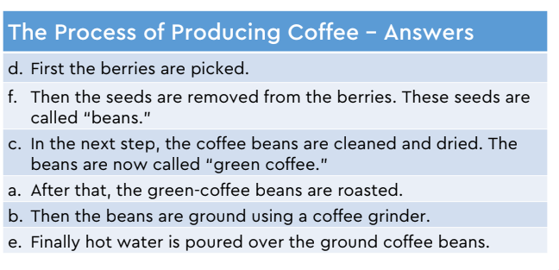

**Present perfect simple or continuous:**

Have/has done or have/has been doing

